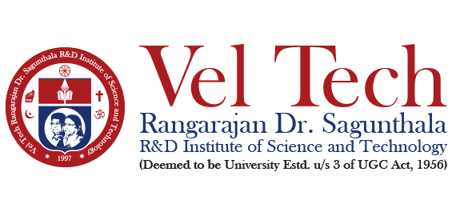
School of Computing
Department of Computer Science and Engineering
Summer Semester 2024-2025
10211CS212- Web and Mobile Application Development
Faculty Name: Mrs. Hemalatha D
Slot: S6+L17 / S14+L1
Batch No:

Title of the Project:- End-to-End Event Lifecycle & Ticketing Platform

Team Members:-
S NO | VTU NO | REG NO | NAME
1. | 26418 | 23UECS1122 | MALEPATI PREM KUMAR REDDY

Abstract:
The End-to-End Event Lifecycle & Ticketing Platform is a web-based application developed to provide an organized and interactive system for managing events and ticket bookings. The project aims to create a user-friendly platform where users can explore categories such as Live Events, Dining, Bookings, and Activities through a well-structured and responsive home page interface. It is designed to offer smooth navigation and an engaging browsing experience for users.At the current stage, the project mainly focuses on front-end development using HTML5 to structure the navigation bar, search section, and icons, CSS3 to enhance visual appearance and responsiveness, and JavaScript to add basic interactivity. This implementation demonstrates the practical application of Unit I concepts such as webpage structuring, styling, event handling, and dynamic web behavior. Although the system is still under development, it provides a strong foundation for integrating database connectivity, user authentication, ticket booking, and transaction management in the complete version of the platform.

Tools Used:
- HTML5
- CSS3
- JavaScript
- PHP (Planned for Backend Integration)
- MySQL (Planned for Database Management)

Web Site Hosting Platform Tool

- XAMPP (Local Server)

Modules:-
- Navigation and Home Page Interface
- Search Functionality (Just UI)
- Event Categories Display
- User Authentication Module (Planned)
- Ticket Booking Module (Planned)
- Payment Module (Planned)

Students Signature Course Handling Faculty

